**JENKINS TASK-01:**

**1.Install Jenkins and run Jenkins on port number 8081:**

Navigate to ec2 in aws and launch a instance.

Instance type is t2-xlarge to have a large memory.

New key pair added.

VPC is default and existing security groups updated as well.

I have updated my EBS as 20 GB for my storage.

Instance launched successfully.

Let’s connect to cli through Public ip and install java-17 version.

Install the Jenkins package and rpm keys. Use the command below.

**sudo wget -O /etc/yum.repos.d/jenkins.repo** [**https://pkg.jenkins.io/redhat-stable/jenkins.repo**](https://pkg.jenkins.io/redhat-stable/jenkins.repo)

Installation of Jenkins package and rpm keys are done and we need to import keys. Use command below.

**sudo rpm --import https://pkg.jenkins.io/redhat-stable/jenkins.io-2023.key**

Now, we shall proceed with installing Jenkins

Installation is successful. We shall start and enable the package.

Now Jenkins is active and shall verify if the port is working as excepted.

Deployment location of Jenkins is /var/lib/Jenkins

We require the password to login into Jenkins, so we need to change directory to Secrets and cat the initial password and we’ll be able to login.

Password updated and logged in successfully.

Now, this is the last part of this task- to change the port number and verify if 8080 to 8081 port number works on browser?

**Default location of file is /usr/lib/systemd/system/Jenkins.service**

Changed the port number and updated the vi.

Now, the port number changed to **8081** and verified in browser. We were able to login and updated the credentials and logged in.

**2.Secure Jenkins server:**

This is the 1st step once connected to port 8080 in website. Click on suggested plugins and continue.

Create a username 🡪 password 🡪 provide an email address and continue.

Now we can securely login into the Jenkins finally.

Let’s verify if the initial password is automatically deleted from the deployment location.

Deployment locationis: **var/lib/Jenkins**

Now change directory to cd secrets to verify if the intial password is avaialble!!

**Success**- The initial password is automatically removed.

**3.Create users called DevOps, Testing in Jenkins with Limited access:**

Navigate to Jenkins 🡪Manage Jenkins and select “Users”

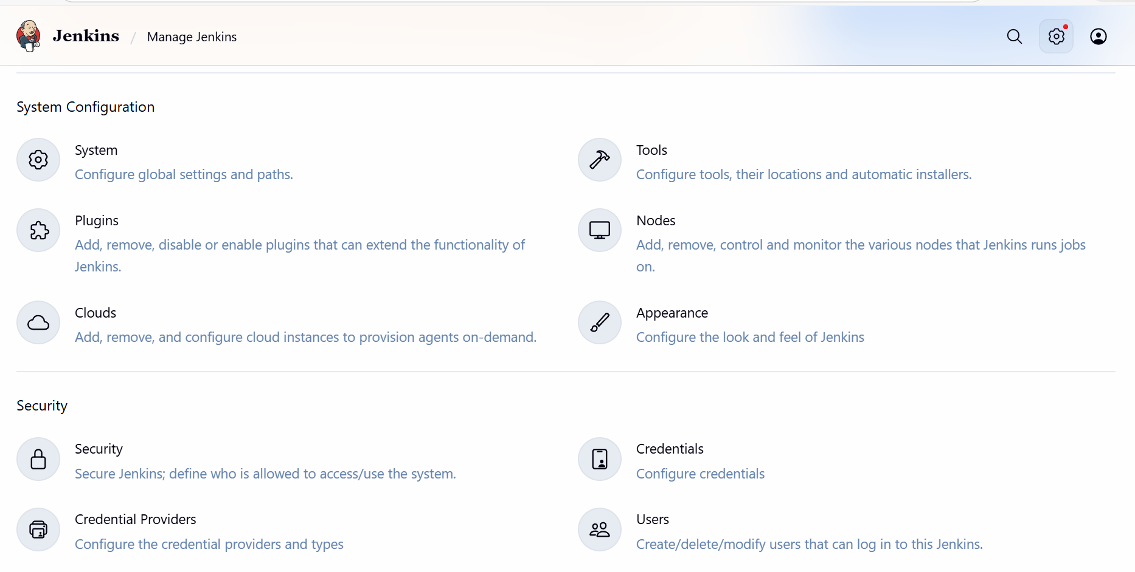

Click on the “Create User”

Create our 1st user- Devops

**Devops** user created.

Create our 2nd user

Created our 2nd user- Testing successfully.

Now, we shall Install plugins to provide limited access to Devops and Testing.

Search for- Role-based Authorization Strategy and Install.

Always, go back to the top page, do not restart Jenkins.

Verified by going back to the plugins and search under Installed Plugins

Navigate to Manage Jenkins 🡪 select Security 🡪 Authorization and select Project-based Matrix Authorization Strategy.

Now, we added 2 users to the Project-based Matrix Authorization Strategy and provided just access to “Job” except delete option.

**4.Configure labels and restrict the jobs to execute based on label only:**

Navigate to Plugins and select available plugins.

Search for Node and Label parameter 🡪Install

Installed successfully.

Navigate to System 🡪 Edit a message- Devops

Select the option as “Only build jobs with label expression matching this node.

Remember- always, we need to install the plugin before creating a job as per requirement.

Create a job now and enter a item name- Devops_Team and choose Freestyle Project.

Update the Label as Devops as we updated earlier in Security under Nodes.

Navigate to GitHub and search for sabear_simplecutomerapp and copy the ssh and paste in the Repository URL.

Yet, got an error Failed to connect, because git is not installed in ec2 server where we have Jenkins installed.

Let’s install git by using command- yum install -y git

**Success-** We can see the git is installed.

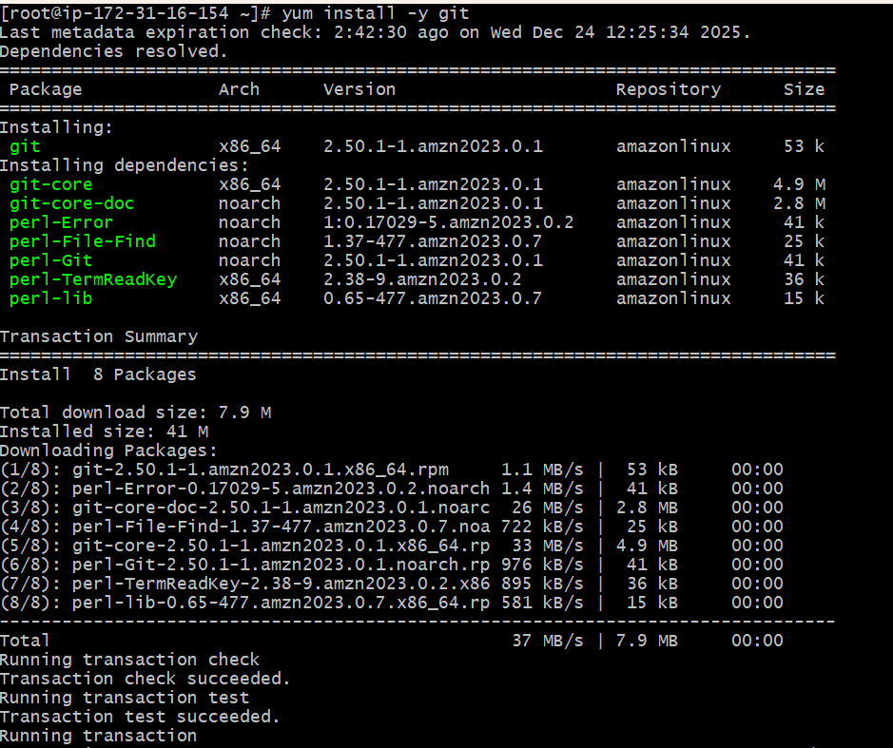

Now the error is not appearing once git installed and 🡪Save

We shall now start Build and check the status.

Success- now the console output says Success.

Status is good and run time is displayed.

We can verify the node is working as expected.

**5.Create Three sample jobs using the below URL.**[**https://github.com/betawins/Techie_horizon_Login_app.git**](https://github.com/betawins/Techie_horizon_Login_app.git)**:**

Create 3 jobs to configure and execute.

Attached the repo link to the Job and save.

Verified in the status- Ready for execute.

Second job ready.

Third Job ready

